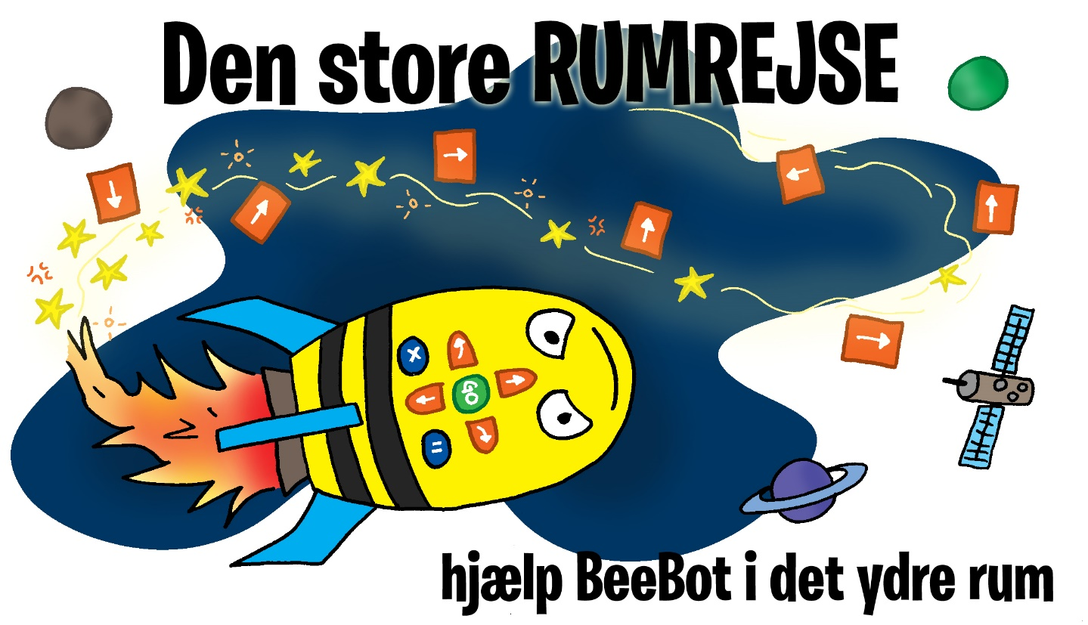
The Great Space Journey
Help BeeBot navigate in space

Trainer manual

BeeBot and the Great Space Journey

BeeBot is a cool little yellow and black robot. It is sweet, helpful and can do a lot of things and you can ask it for help regarding almost anything. It never says no, you just have to ask it the right thing. BeeBot is a curious little robot that has been assigned the task of helping with some tasks in outer space - it is a task that fits perfectly with a small robot like BeeBot, it can easily fly around outer space.
Task 1: Alien bacteria
A swarm of possibly dangerous alien bacteria has been found on the way to Earth. Hurry to find anti-virus and fly out to kill the bacteria (neutralize them).

Task 2: The broken satellite
One of the satellites has broken - it lacks power and the signal has disappeared. Find tools and a new solar panel, fly out and repair the satellite in a hurry.

Task 3: Chain the three satellites together
Three of the satellites that normally “talk” together for us to use mobile phones on Earth have lost their connection. Grab the tools and a new digital satellite chain to re-link the 3 satellites. (BeeBot must "fly” over all three satellites)

Task 4: Opgave 4: Find Mercury
It is extremely strange! The planet closest to the sun has disappeared. Find the Space telescope and fly out to see if you can spot Mercury.

Task 5: Plant the BeeBot-flag
Put BeeBot's flag on the Moon. In order to live on other planets, one must be able to land on them first. Find the BeeBot flag and plant it on the Moon.

Task 6: move the persoanal-module to the Space station
To be able to live in space, the conditions at the space station must be completely in order and adapted to people. Have the BeeBot fly the personal module out to the space station.

Task 7: Explore the outer rim of the Milky Way
To infinity and beyond! Find the Space telescope and go exploring the outer Milky Way - remember to think sustainably so that the fuel is sufficient for the journey.

Help BeeBot solve the 7 tasks.
assignment requirements are described in the games and code booklet

Construction Task:
The team must construct a space station for the Game-field and a spaceship / space rocket. The requirements are described in the code and game booklet.
How a BeeBot works
Drive 1 step forward
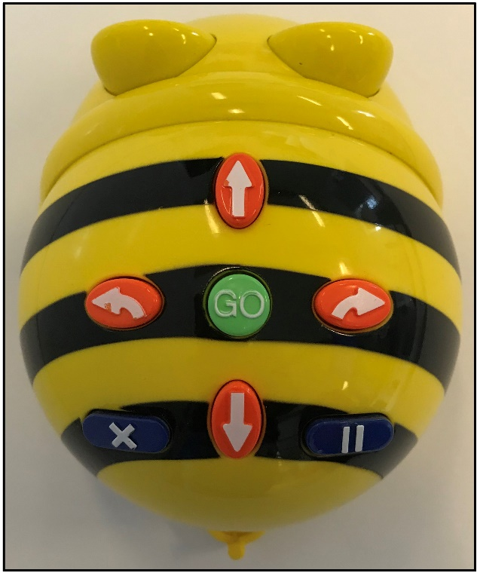
Drive 1 step backwards
Start program
Reset BeeBot
to next code-string
IMPORTANT
Turn left
Turn right
Pause (not in use)

Rules

You have to make a building for the empty "building site" of the game-field. The building will be the team's space station and it will be on the game-field for "The Great Space Journey" on the competition day and will be judged by the judges. You get points for the building. You can read about the rules for the space station and the rating in the game and code booklet.

Note: BeeBot cannot drive through the space station area!

BeeBot must start from one of the 3 possible take-off fields each time you start a new task. You choose whether BeeBot has to do the tasks one at a time or several tasks at once. You can NOT start from the same take-off field twice in succession, you must select a new take-off field.

Write your codes in your game and code booklet so you can remember them for "The Great Space Journey" on the competition day. BeeBot is not allowed to drive through the walls on the track (the red lines), nor is BeeBot allowed to drive through the black holes on the track. If BeeBot hits a black hole, it is moved back to the team, so that theyt can re-code BeeBot.

It is important to collect as many points as possible in 3 laps, every lap is 5 minutes.

The tasks are solved when BeeBot has collected the items needed to solve the task (resource chips), and moves to the task-area and stops. BeeBot should not return to one of the starting fields. When BeeBot reaches the taskbar and solves the task, the team can take the robot home.
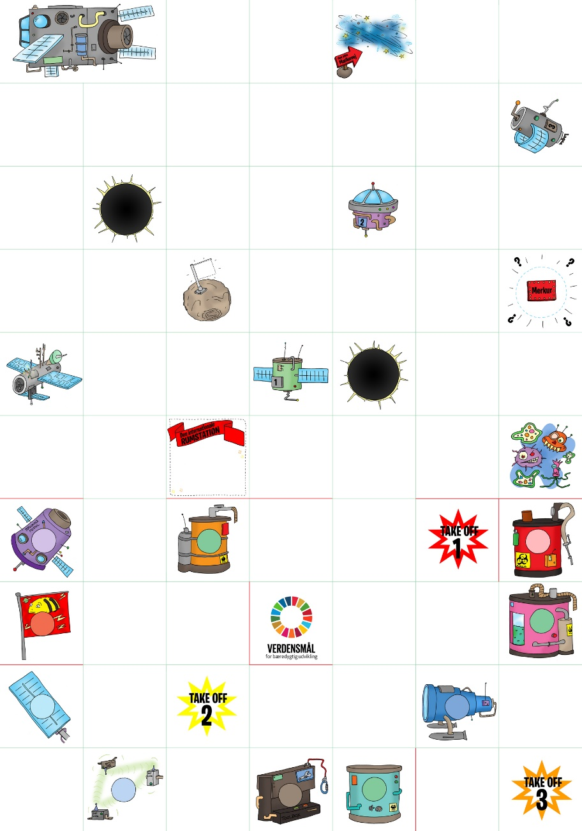
The game-field: 7 x 10 areas of 15 x 15 cm.
Two versions of the game-field:

A training edition with a green grid that helps participants visually count fields and practice their codes, etc.
A competition version without the green grid, for the final competition where the codes should be written down perfect.
The red lines on the game-field itself are walls, where the team must produce some kind of wall approx. 1 cm in width and 1-3 cm in height and bring these walls on the competition day itself.

Let's fly out into space!

Voluntary assignment

You are allowed to decorate your BeeBot so it looks really nice and cute. Surely it could be even more nice if decoration fits the theme? Remember to be careful so that your BeeBot can ”fly” around the game-field without getting stuck or knocking something over.

Start and trainer assistance

You may want to build a template for the starting fields to help the children set BeeBot right when it starts.
The trainer may enter the code for the participants if the participant cannot physically enter the code themself.
Extra Sustainable Assignment

Build a spaceship or space rocket to help improve the climate of the Earth according to the SDG’s. The rocket must in some way be driven by a force or have a relation to something supported by one or more of the SDG’s or sub-goals - likewise, the spaceship or rocket may be built / constructed of materials that reflect sustainability.
Read about the SDG’s on the internet.

Resource Tokens

It is important to collect resource tokens to solve the tasks on the field. The ressource-token-area on the game-field matches a classic milk lid from school milk (in Denmark). Whether you want to make the pieces in wood, clay, 3Dprint or something different is up to the trainer and team. The illustrations for the pieces can be cut out and glued to the physical tokens.

(The following page shows the resource tokens from The Great Space Journey)
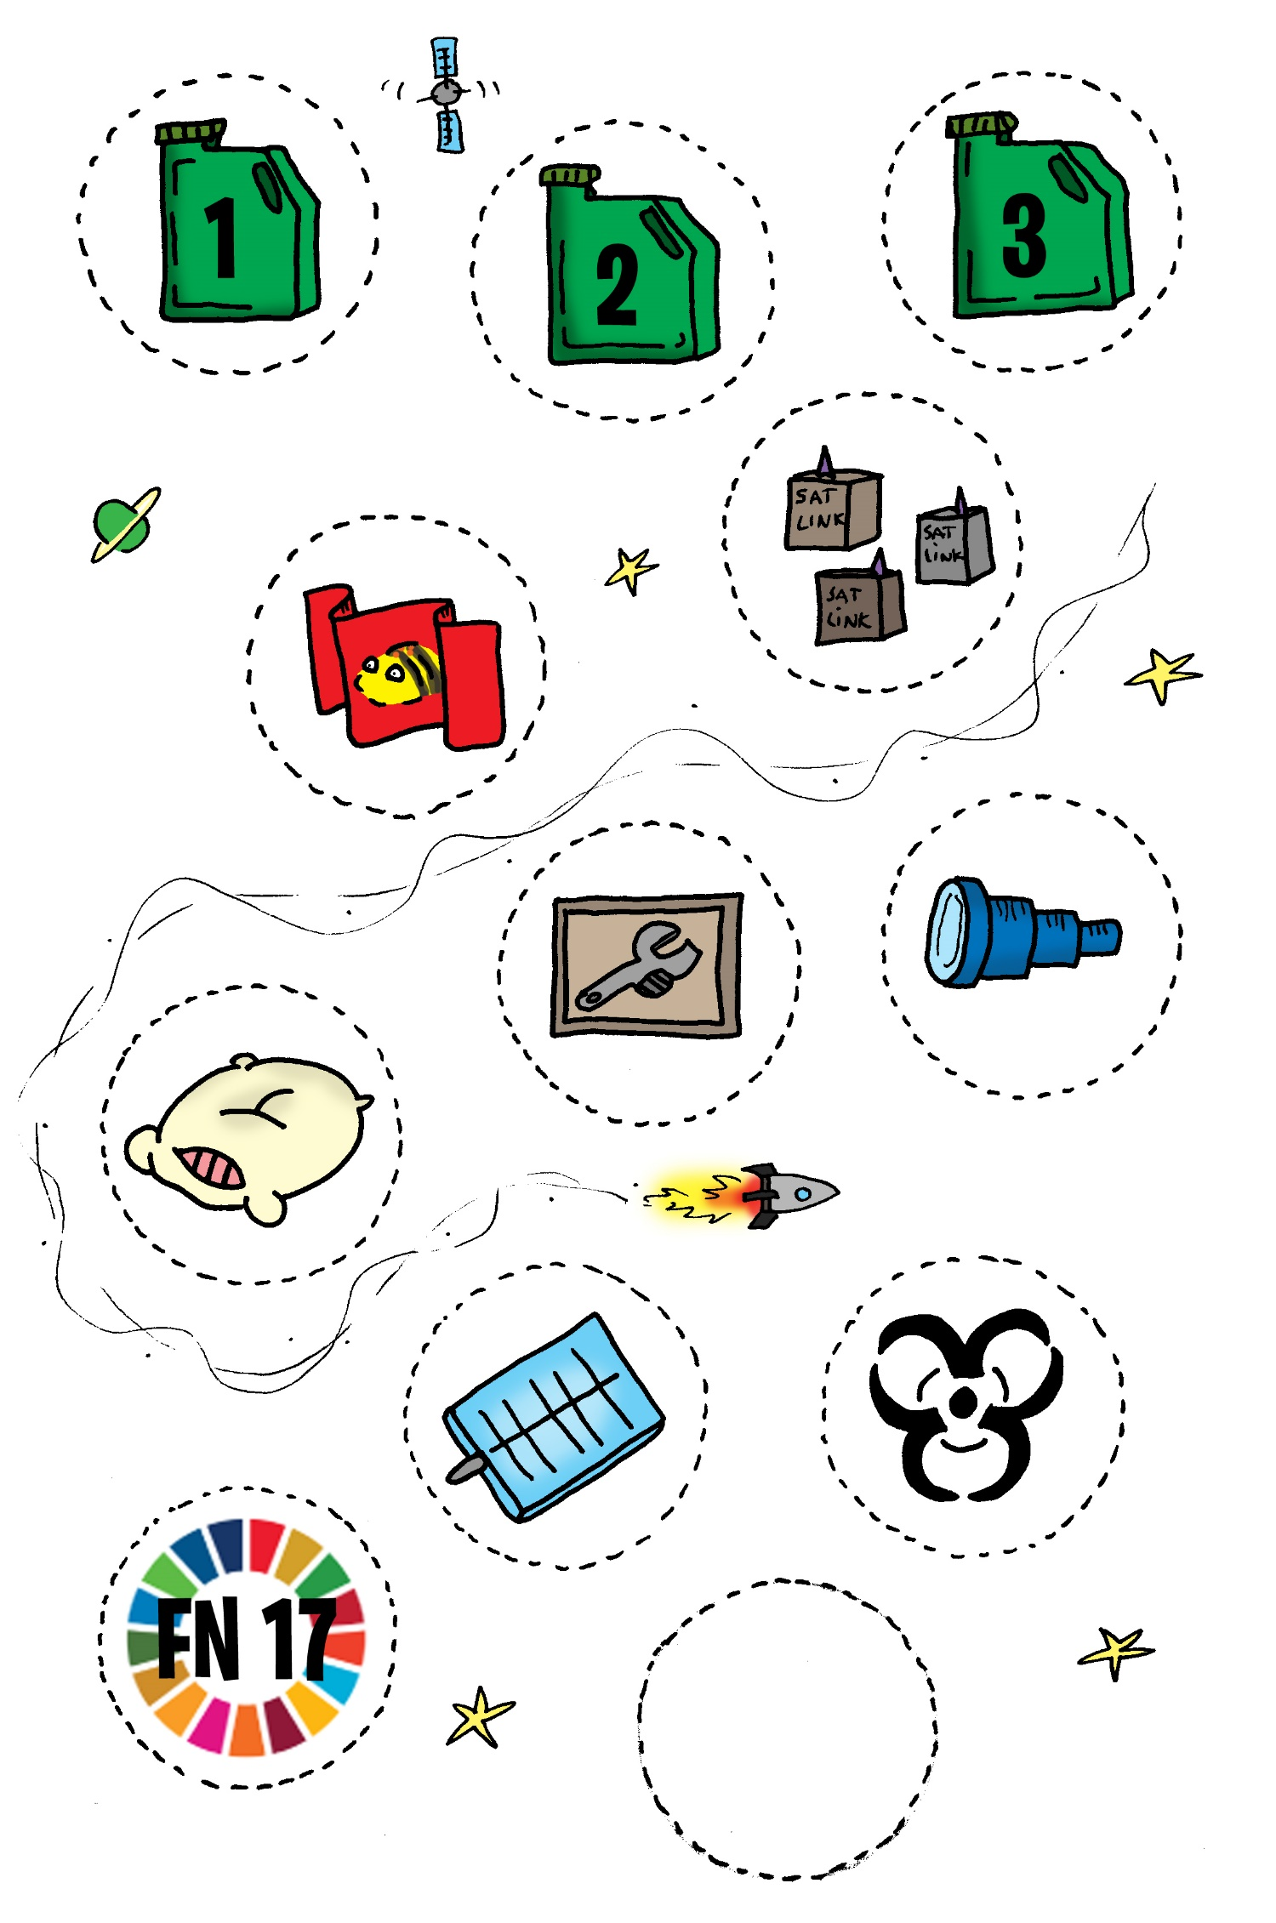
SDG
How to gather and store Rocket Fuel:

The team collects fuel by retrieving the various resource tokens on the game-field. The team can fetch 1, 2 or 3 units of fuel by running out to the resource areas. The team will need different amounts of fuel to fly BeeBot from the take off locations to the tasks on the game-field. But not only will the team need fuel to send BeeBot off, it will also consume fuel to complete the tasks. Each time the team solves a task it costs 1-2 fuel units (the team can see the number of fuel units in the play and code booklet during the task).

To keep track of fuel and consumption, each team has a fuel tank and fuel gauge. It is the referee (or trainer) who has to make sure to move the fuel gauge so the team always knows, what they are dealing with.

The team must, in their planning and strategy for the order the tasks are solved in, of course, calculate both their content of the fuel tank, but also their consumption. Maybe BeeBot needs to pass a fuel resource more than once.

The team fuel tank can contain a maximum of 6 fuel units.

On the following two pages you will find the team's fuel tank and fuel gauge. On the fuel tank side, the two black fields are cut out at 0 and 6, so that the cut fuel gauge can be moved up and down according to content and consumption.
(as showed below)

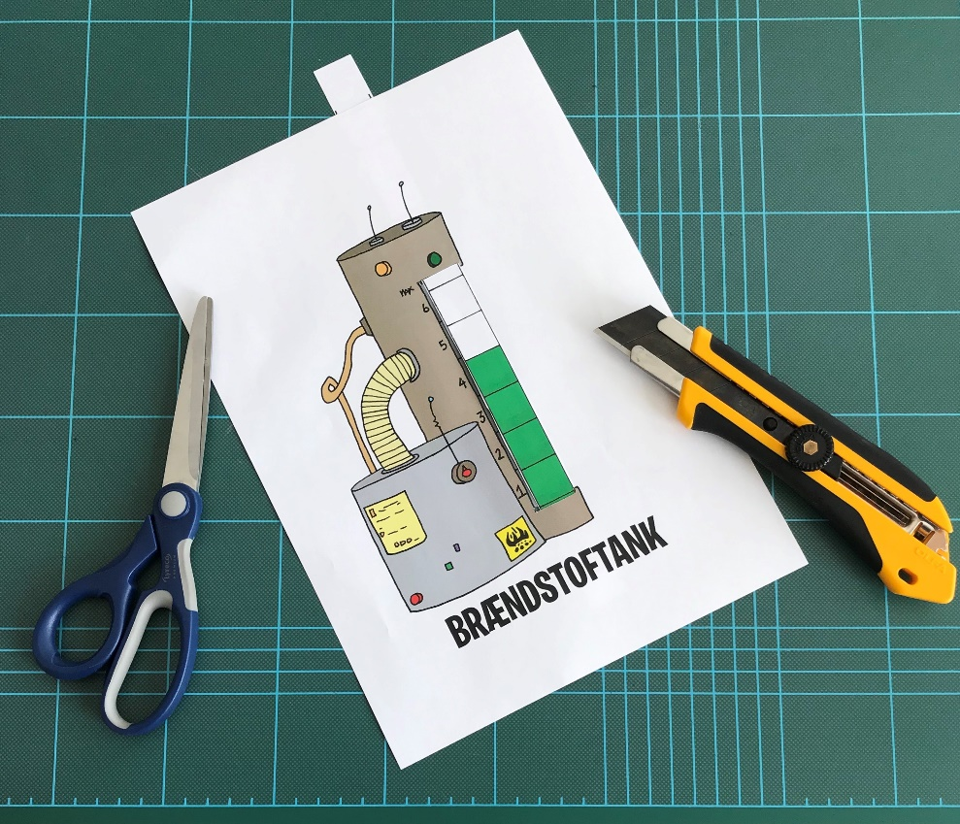

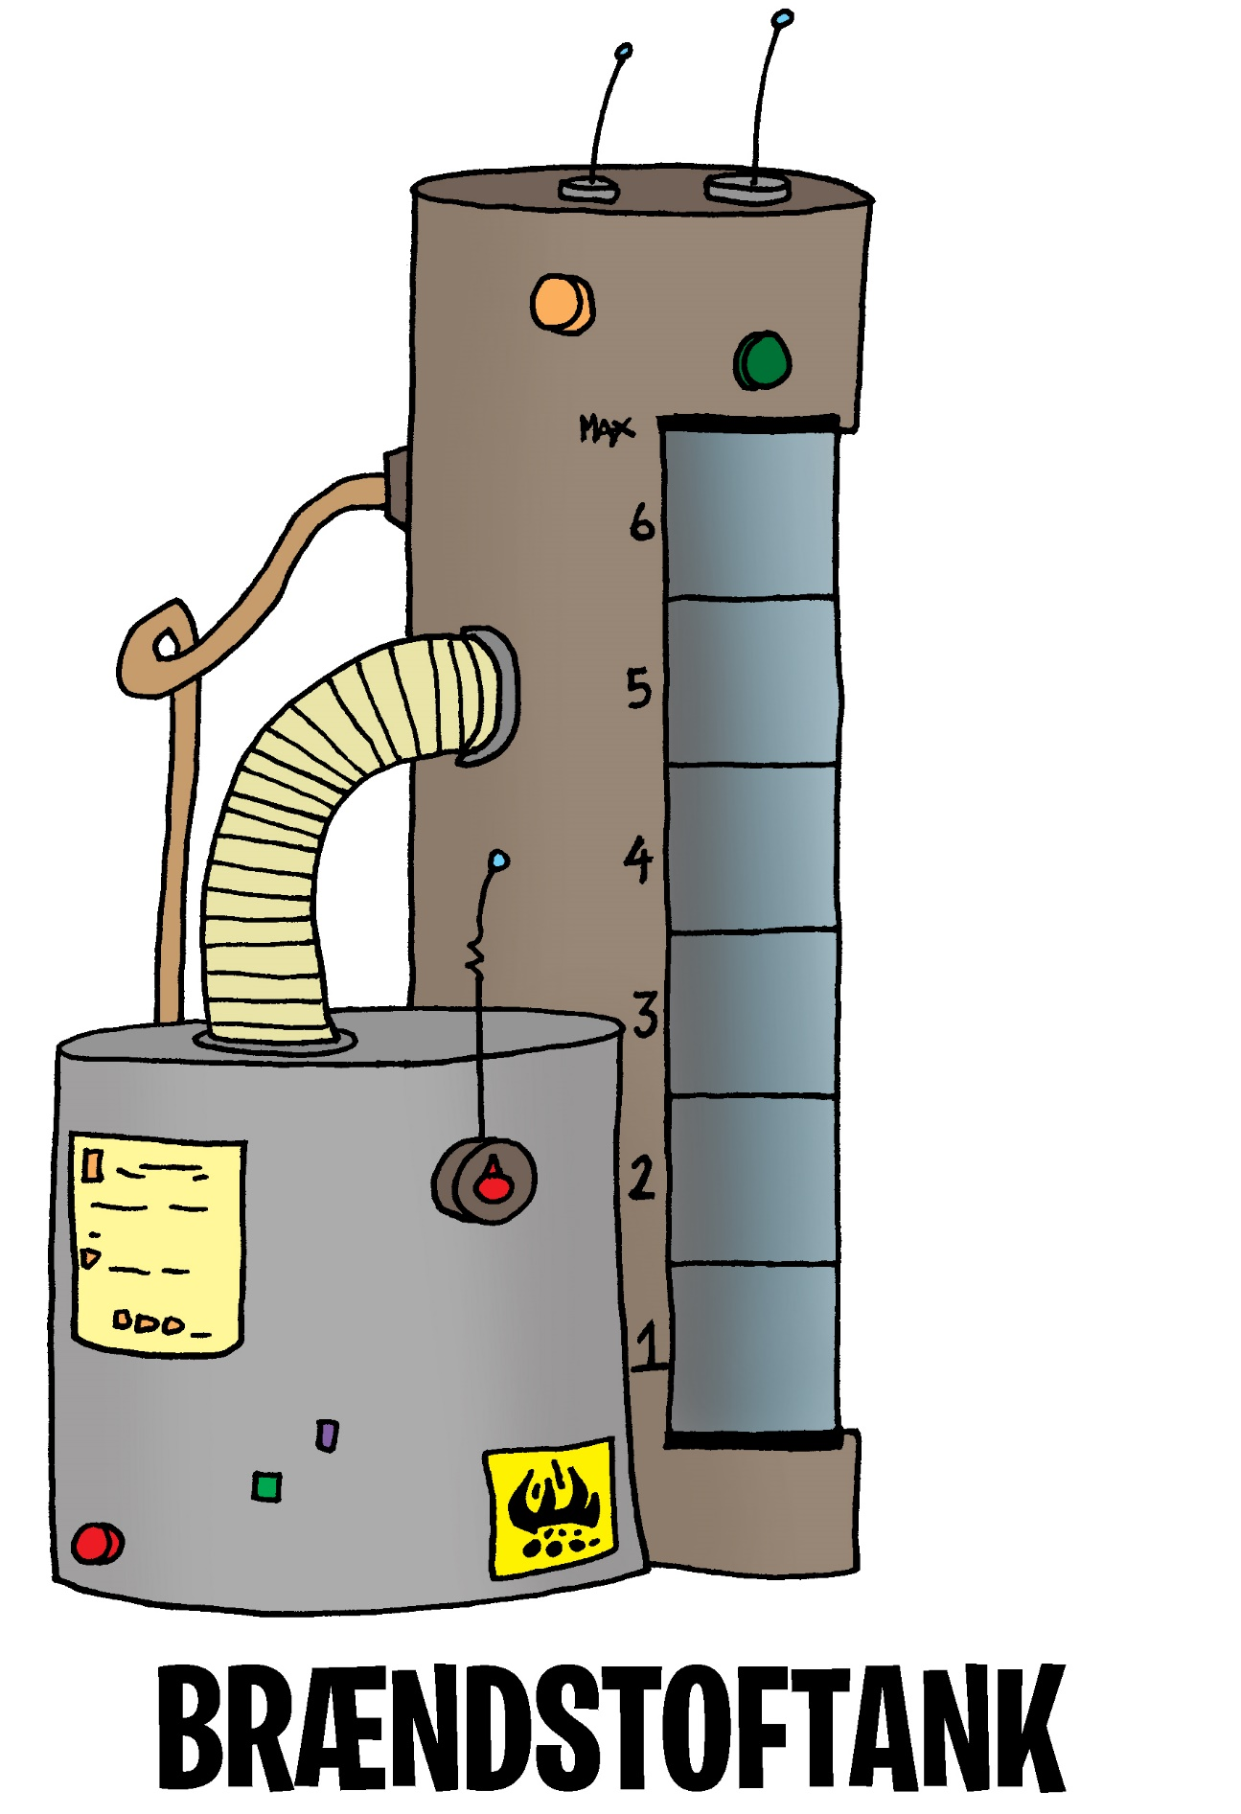
The big Fuel tank

