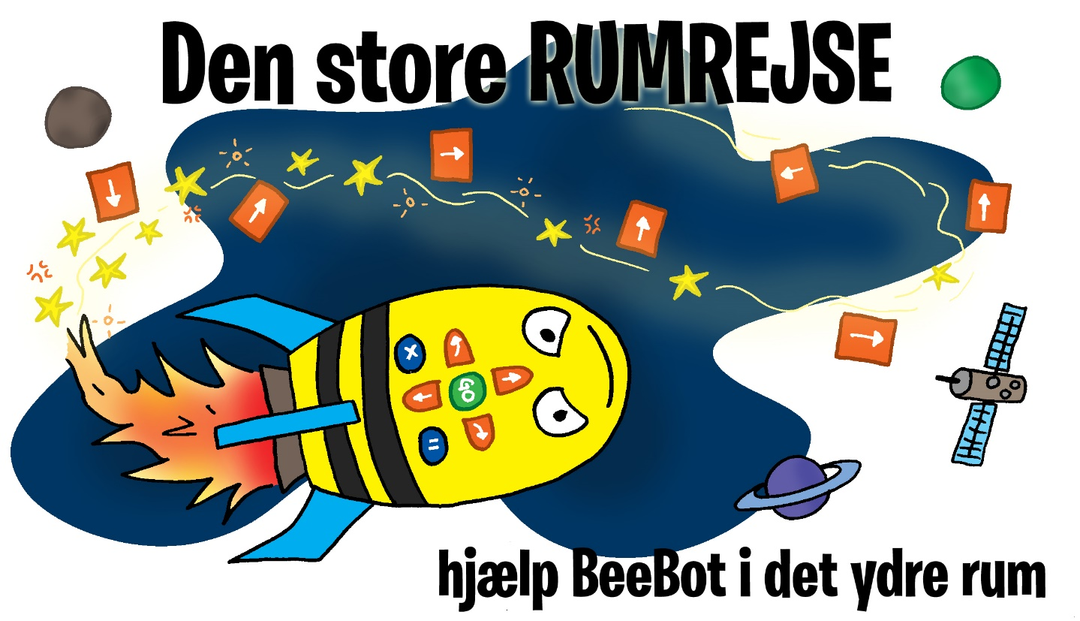
The Great Space Journey
Help BeeBot navigate in space

Game- and code book

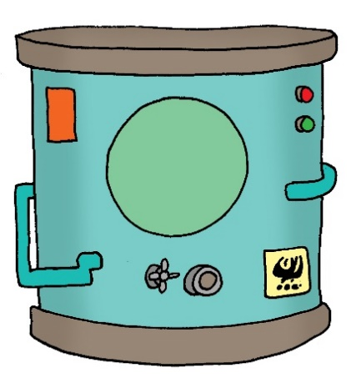 | Fuel tank niveau 1  1 x Rocket fuel  Where does BeeBot start and witch direction (Take Off spot)  1 2 3  Draw your ”code-arrows” here  Remember to use a pencil (it’s easier to erase)
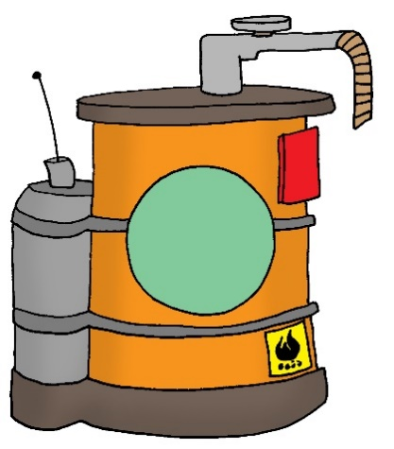 | Fuel tank niveau 2  2 x Rocket fuel  Where does BeeBot start and witch direction (Take Off spot)  1 2 3  Draw your ”code-arrows” here  Remember to use a pencil (it’s easier to erase)
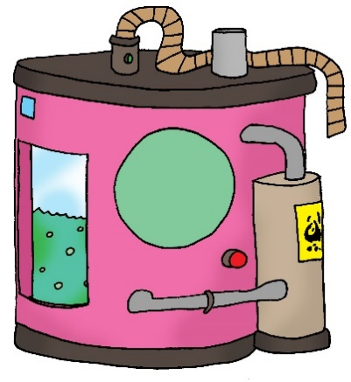 | Fuel tank niveau 3  3 x Rocket fuel  Where does BeeBot start and witch direction (Take Off spot)  1 2 3  Draw your ”code-arrows” here  Remember to use a pencil (it’s easier to erase)
SDG | The Sustainable Development Goals  1 x Sustainability  Where does BeeBot start and witch direction (Take Off spot)  1 2 3  Draw your ”code-arrows” here  Remember to use a pencil (it’s easier to erase)
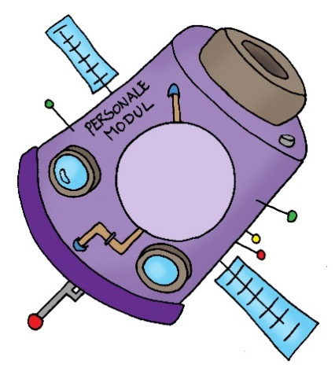 | Personal modul  1 x Personal modul to the spacestation  Where does BeeBot start and witch direction (Take Off spot)  1 2 3  Draw your ”code-arrows” here  Remember to use a pencil (it’s easier to erase)
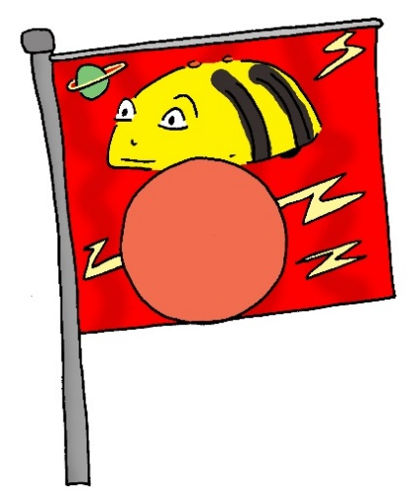 | BeeBot flag  1 x Flag  Where does BeeBot start and witch direction (Take Off spot)  1 2 3  Draw your ”code-arrows” here  Remember to use a pencil (it’s easier to erase)
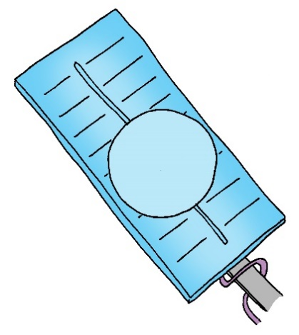 | Solar panel  1 x Solarpanel  Where does BeeBot start and witch direction (Take Off spot)  1 2 3  Draw your ”code-arrows” here  Remember to use a pencil (it’s easier to erase)
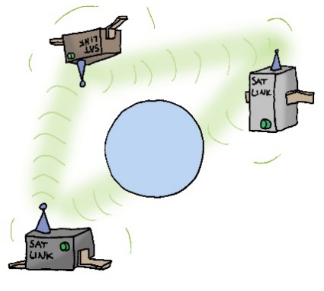 | Digital ”chain”  For connecting satellites  1 x Digital ”chain”  Where does BeeBot start and witch direction (Take Off spot)  1 2 3  Draw your ”code-arrows” here  Remember to use a pencil (it’s easier to erase)

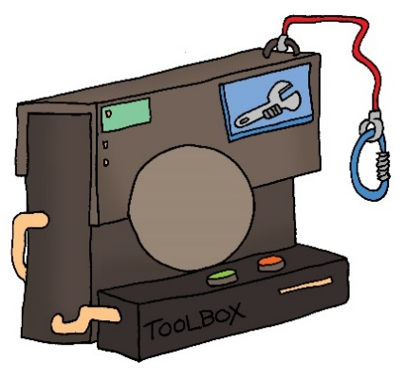 | Toolbox  1 x Toolbox  Where does BeeBot start and witch direction (Take Off spot)  1 2 3  Draw your ”code-arrows” here  Remember to use a pencil (it’s easier to erase)

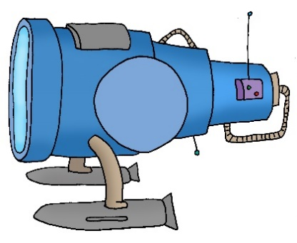 | Space telescope  1 x Space telescope  Where does BeeBot start and witch direction (Take Off spot)  1 2 3  Draw your ”code-arrows” here  Remember to use a pencil (it’s easier to erase)

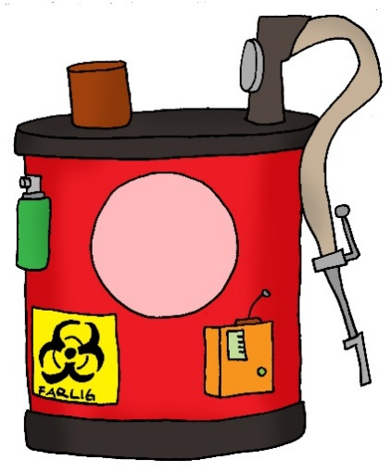 | Antivirus for defeating alien bacteria  1 x Antivirus  Where does BeeBot start and witch direction (Take Off spot)  1 2 3  Draw your ”code-arrows” here  Remember to use a pencil (it’s easier to erase)

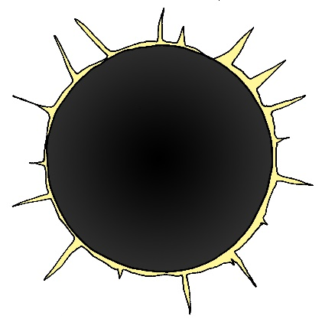  Black hole  YOUR SPACESTATION | Obstacles  There are some different spaces on the  Game field, where your BeeBot spaceship can’t go:  The two Black holes on the game-field are obstacles, your have to navigate around.  You’re not allowed to ”fly” your BeeBot spaceship on to the area of your own Spacestation
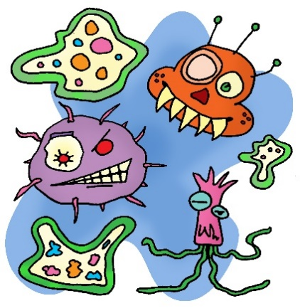 | Defeat the alien bacteria  The task requires:  3 x Rocket fuel  1 x Antivirus  Task solved:  8 point  Task cost:  1 Rocket fuel  Where does BeeBot start and witch direction (Take Off spot)  1 2 3  Draw your ”code-arrows” here  Remember to use a pencil (it’s easier to erase)

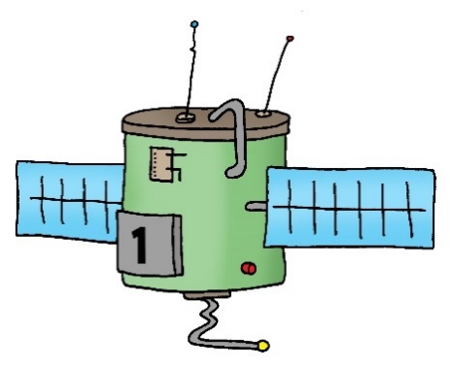  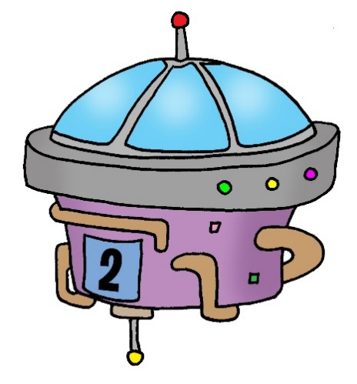  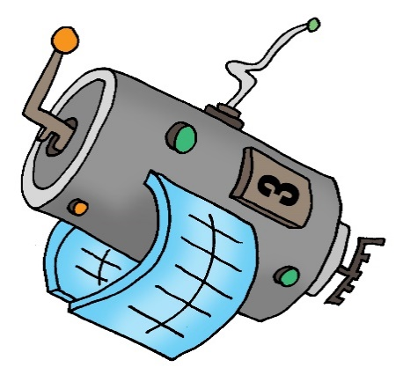 | ”Catch” the 3 satellites  and chain them back together  The task requires:  4 x Rocket fuel  1 x Digital ”chain”  Task solved:  15 point  Task cost:  2 Rocket fuel  Where does BeeBot start and witch direction (Take Off spot)  1 2 3  Draw your ”code-arrows” here  Remember to use a pencil (it’s easier to erase)
Your Space station | Buildingsite - Your Space station  The task requires:  The team must bring their own beautiful, creative and imaginative space station to the competition. The basic dimensions should be max.14 cm x 14 cm and in a height of between 5 and 50 cm.  The judges scores from 0 to 20 points based on:  Aesthetic appearance 0 - 5 points  Material selection 0 - 5 points  Construction 0 - 5 points  Relation to the theme 0 -5 points  +5 points for using technology (light / sound etc.)  +1 points extra per centimeters as the bottom of the space station is lifted from the game-field.  In addition to the space station, each team must build a space rocket or spaceship and bring to the competition day.  As such, the space rocket or spaceship has no function on the game-field, but extra points from 0-5 can be awarded for the construction.
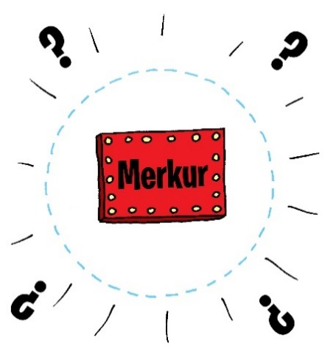  Mercury | Mercury has disappeared  The task requires:  4 x Rocket fuel  1 x Space telescope  Task Solved:  12 point  Task cost:  1 Rocket fuel  Where does BeeBot start and witch direction (Take Off spot)  1 2 3  Draw your ”code-arrows” here  Remember to use a pencil (it’s easier to erase)
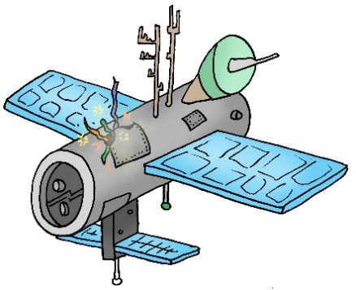 | Broken satellit  The task requires:  4 x Rocket fuel  1 x Toolbox  1 x Solar panel  Task solved:  14 point  Task cost:  1 Rocket fuel  Where does BeeBot start and witch direction (Take Off spot)  1 2 3  Draw your ”code-arrows” here  Remember to use a pencil (it’s easier to erase)
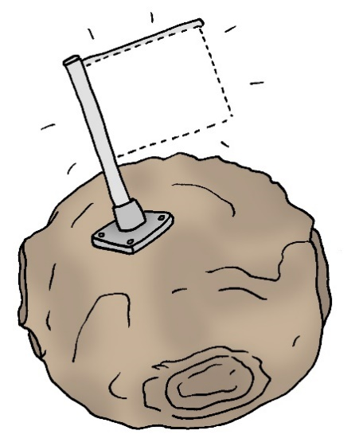 | Plant the BeeBot flag  The task requires:  4 x Rocket fuel  1 x BeeBot flag  Task Solved:  11 point  Task cost:  1 Rocket fuel  Where does BeeBot start and witch direction (Take Off spot)  1 2 3  Draw your ”code-arrows” here  Remember to use a pencil (it’s easier to erase)
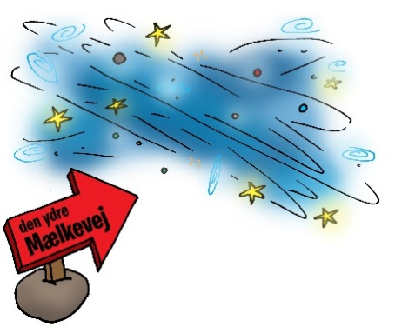  The Milky Way | Explore the outer rims of the  Milky Way  The task requires:  5 x Rocket fuel  1 x Space telescope  1 x Sustainable development goals  Task solved:  20 point  Task cost:  2 Rocket fuel  Where does BeeBot start and witch direction (Take Off spot)  1 2 3  Draw your ”code-arrows” here  Remember to use a pencil (it’s easier to erase)
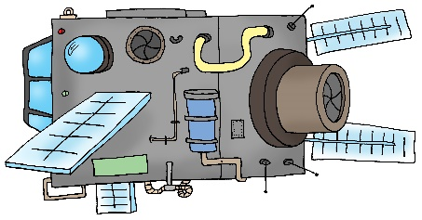 | Put personel in the Spacestation  The task requires:  5 x Rocket fuel  1 x Personal modul  Task solved:  18 point  Task Cost:  2 Rocket fuel  Where does BeeBot start and witch direction (Take Off spot)  1 2 3  Draw your ”code-arrows” here  Remember to use a pencil (it’s easier to erase)

